
CSA: Community Supported Agriculture
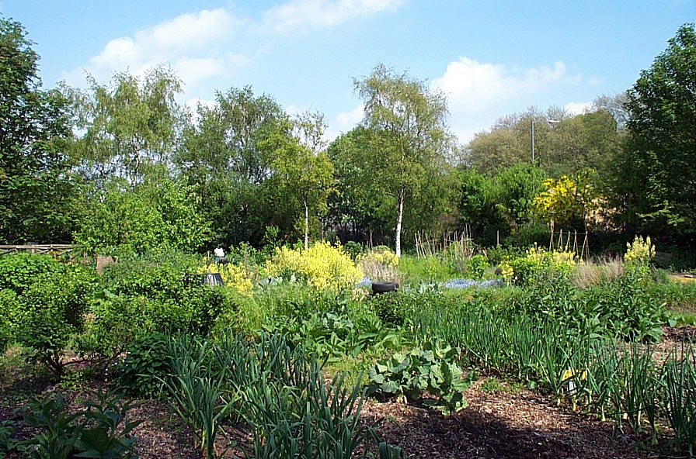
Allotment, Windmill Hill City Farm, Bristol
Source: http://www.windmillhillcityfarm.org.uk
A Summary
CSA (Community Supported Agriculture) or community farming is a low-carbon method of providing local people with sustainably produced food. Some of its main principles include:
- Contributing to a sustainable local economy
- Lowering ‘food miles’
- Providing fresh, locally-grown/sourced produce
- Utilising environmentally-sensitive methods of farming
CSA focuses on bringing diverse community groups together and can inspire a variety of projects. Members of a CSA group share the pleasure of directly supporting a local farm in exchange for fresh, seasonal produce. There are obvious health benefits of having access to such a diet, alongside the opportunity to learn new skills and keep fit outdoors. Members commit financially to support the farm and/or contribute to the production and upkeep. This assures a secure, grass-roots connection and helps to employ more permanent growers and supply equipment on bigger farms.
Each member shares a responsibility for the farm’s existence and productivity. This can be a rewarding experience, bringing local families and individuals together at harvesting events, for example. From an economic perspective such groups can cooperate with other local independent businesses and support farmers markets.
The Soil Association is an example of an organisation that can provide support for communities interested in CSA via their ‘Making Local Food Work’ campaign. Their CSA project supports new farms and advises local communities:
“The CSA approach is possibly the ultimate in achieving a self-sustaining localised food and farming system. CSA offers an innovative business approach where a food or farm enterprise has members who own ‘shares’ in the harvest and therefore also share in the risk.”
Source: http://www.soilassociation.org/foodandfarming
Community farms can form connections with wider members of the community such as local councils, schools, educational institutions and voluntary organisations. Organic farming methods and permaculture techniques have a positive effect on the landscape and conserving wildlife. CSA is a holistic method of sustainably utilising neglected green spaces in urban and rural communities. It is also a positive method of mitigating the global impacts of climate change and peak oil.
Mitigating Climate Change and Peak Oil - Why Cheltenham needs Community Farms
Our changing climate alongside the lesser-publicised issue of peak oil is forcing communities across the world to change the way they live. This June, the ‘New Scientist’ reported a survey of oil industry experts, which found that most of them believe that half of the total global reserves of oil will be used by 2010. This is known as peak oil where easily accessible reserves will be exhausted and it will become progressively more energy-intensive and expensive to extract the remaining oil. In combination with population increase and increasing demands from developing countries such as India and China, this will lead to massive increases in the price of oil as demand outstrips the ability to supply.
Since intensive farming is heavily dependant on oil and already suffering from the effects of ecosystem degradation and climate change, the cost of producing, processing and importing food will rise significantly. According to a report from 2004, entitled, ‘Oil depletion: no problem, concern or crisis’, 95% of all food products requires oil use. In the fuel protests of 2000, the chairman of Sainsbury’s warned Tony Blair that the UK was days away from foodless supermarkets. This summer, Lord Cameron, a farmer and first head of the Countryside Agency coined the expression: ‘nine meals way from anarchy’. In his estimation it would take just nine meals or three days without food on supermarket shelves, before law and order started to break down. This would be the case if there was no oil or an interruption to supply. This may sound far-fetched but those who were left in New Orleans after Hurricane Katrina were reduced to looting for food. Communities need to shift from relying on 150 years of abundant cheap oil to alternative ways of producing food and more sustainable life styles, as stated below by the Transition Town Network:
“Regarding the world economy and the consumptive patterns within it, as long as the laws of physics apply, infinite growth within a finite system (such as planet earth) simply isn't possible.”

Source: The Transition Initiatives Primer

CSA is a valuable way of encouraging communities to provide affordable food as prices increase and adopt low-carbon lifestyles. It is a prime example of dealing with major global issues in a local context. It revives the value of a strong, localised economy and utilises neglected green spaces for all to enjoy.
The Threat of Climate Change and Peak Oil – The context for planning for Food Security
A report published by the US Department of Energy in 2005, argued that unless the world begins a crash programme of replacements ten or twenty years before oil peaks, a crisis “unlike any yet faced by modern industrial society” is unavoidable. The ‘green revolution’ in agriculture that has increased crop yields is due to fossil fuel based fertilizers and chemical pesticides and herbicides. A report by the UN published in August 2008 shows that fertilizer prices have doubled in a year and in some cases by 500% as oil prices rapidly increase. This has lead to India and China hoarding fertilizers to guarantee food stocks. In the past fourteen months rock phosphate, which makes phosphorous used in industrial fertilizers has increased in price by 700%. Demand is soaring and reports vary over when this essential resource is likely to peak – one says it may have occurred, another within three decades. What is clear is that we must end our dependence on artificial fertilizers and grow our food organically.
This year has also seen food riots and protests in over forty countries as global food prices have increased by 75% within the year. The price of wheat, increased by 130% in twelve months. In Asia, the price of rice doubled in just three months, leading to farmers sleeping in their fields with Kalashnikovs to ward off rice-rustlers. The World Bank has warned that 100 million more people are facing hunger and malnutrition because of rising food prices. In April 2008 the EU said that ‘the era of cheap food is over’. In May 2008 the Organisation for Economic Co-operation and Development (OECD) and the UN Food and Agricultural (FAO) forecast that food prices will remain high for a decade. Increased prices in bread, wheat and dairy products are already affecting the poor in the UK.
Climate change will affect global crop yields. The Stern Review highlights how global warming will reduce crop yields in Africa. A report published by Stanford University in February 2008 forecast that climate change will lead to severe crop losses in South Asia and Southern Africa in the next twenty years. These are countries that currently export food to the UK. It is possible that this years crop losses in Kenya, Mozambique, Zimbabwe, North Korea and Bangladesh were caused by climate change.
Food security and food sovereignty are no longer the concern of small-holders and pastoralists in the global South. In the past couple of months Gordon Brown and Prince Charles have recognised that as in World War II, it is vital that the UK is self-sufficient in its food supply. With oil and gas peaking, this will need to be organic, which means a greater use of land for agriculture.
Vision 21 (Gloucestershire) recommends the documentary ‘The Power of Community’ which is an inspiring film that shows how an urban society can make the transition to growing their own food. The film shows how Cuba dealt with losing its oil supplies during the Cold War. Vision 21 can arrange for a screening of this film or lend out the DVD.
Examples of CSA Initiatives in the South West
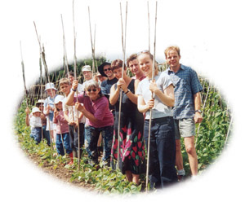
There are a variety of CSA projects, shared allotment spaces and other community farming initiatives throughout the UK from which to draw inspiration. An example of one highly successful movement is the Transition Towns Network, which advocates the necessity of communities becoming as resilient as possible to the impacts of climate change and peak oil. The Soil Association, as mentioned above, has recently secured funding to give greater support to new CSA initiatives.
Stroud (opposite photo, from Stroud Community Agriculture website) has a thriving CSA of six years. It is renting 50 acres and provides vegetables and meat to 180 households (300 people). It employs two full time farmers. Interesting only five acres are devoted to vegetables or 10% of the land, which indicates how much land is required for rearing livestock and our energy needs – the farm also supplies all wood fuel needs for the families. Approximately half an acre is required per person for all food and wood fuel needs. Stroud Community Agriculture has very kindly sent us their Annual Report which we can make available to you to help answer specific queries.
Windmill City Farm in Bristol is an example of another established community farming initiative, described on their website as follows:
“The community gardens are made up of plots where local residents grow their own vegetables, fruit and flowers. There are communal areas with flower gardens and an ornamental pond. The horticultural centre includes a greenhouse, polytunnel and cold frames. “
Source: http://www.windmillhillcityfarm.org.uk
It is open for public viewing and involvement, closely linked to schools and runs a variety of educational programmes relating to sustainable living, wildlife conservation and food. Such projects are thriving examples of the diversity and holistic perspectives CSA can inspire.
Stroud Communal Allotment Group, which supports seven families, is an example of how smaller areas of green space can also be effectively utilised. They support themselves through the summer months with the vegetables grown and any excess are sold in boxes locally for LETS (local exchange trading system). LETS allows individuals to exchange services and produce. This is another community-focused method of sharing knowledge and skills, as well lowering food miles and protecting the environment with ecologically-aware farming techniques.
Funding Opportunities
There are many funding opportunities for local food initiatives available including some grants of up to £300 k. For example, there is the Big Lottery fund and within that the ‘Changing Spaces’ programme that would be suitable for a local CSA project.
Community Benefits
- Community - building community resilience through linking different groups in the community and providing opportunities for networking and information sharing between community groups;
- Educational – learning growing skills; developing understanding and awareness of food production; skills sharing to boost self-confidence; informal exchange of skills knowledge usually at no cost – free training;
- Economic - improve opportunities for local employment; better choice for the local consumer;
- Health – increase participation in outdoor activity; reconnecting people with land provides mental health benefits;
- Environmental – less waste to landfill through composting; less carbon emissions from food; less chemicals in food production; less oil and energy consumption in food production.
Conclusion
CSA is bringing resilience to local people, to bring them closer together through potentially difficult economic periods. It has the potential to inspire and revive communities, as initiatives such as Transition Towns and various Soil Association case studies show. In Gloucestershire we do not have to look far to see some thriving examples and discover the diversity these fulfilling movements can bring.
Report Author: Sarah Taylor
Gloucestershire University student: MSc Environmental Policy and Management
Vision 21 (Gloucestershire) Volunteer
With assistance from:
Chris Budden, Ian Lander, Cathy Green (Vision 21 Gloucestershire)
Arran Stibbe (University of Gloucestershire)

